EC2 Instance Running
EC2 Instance Running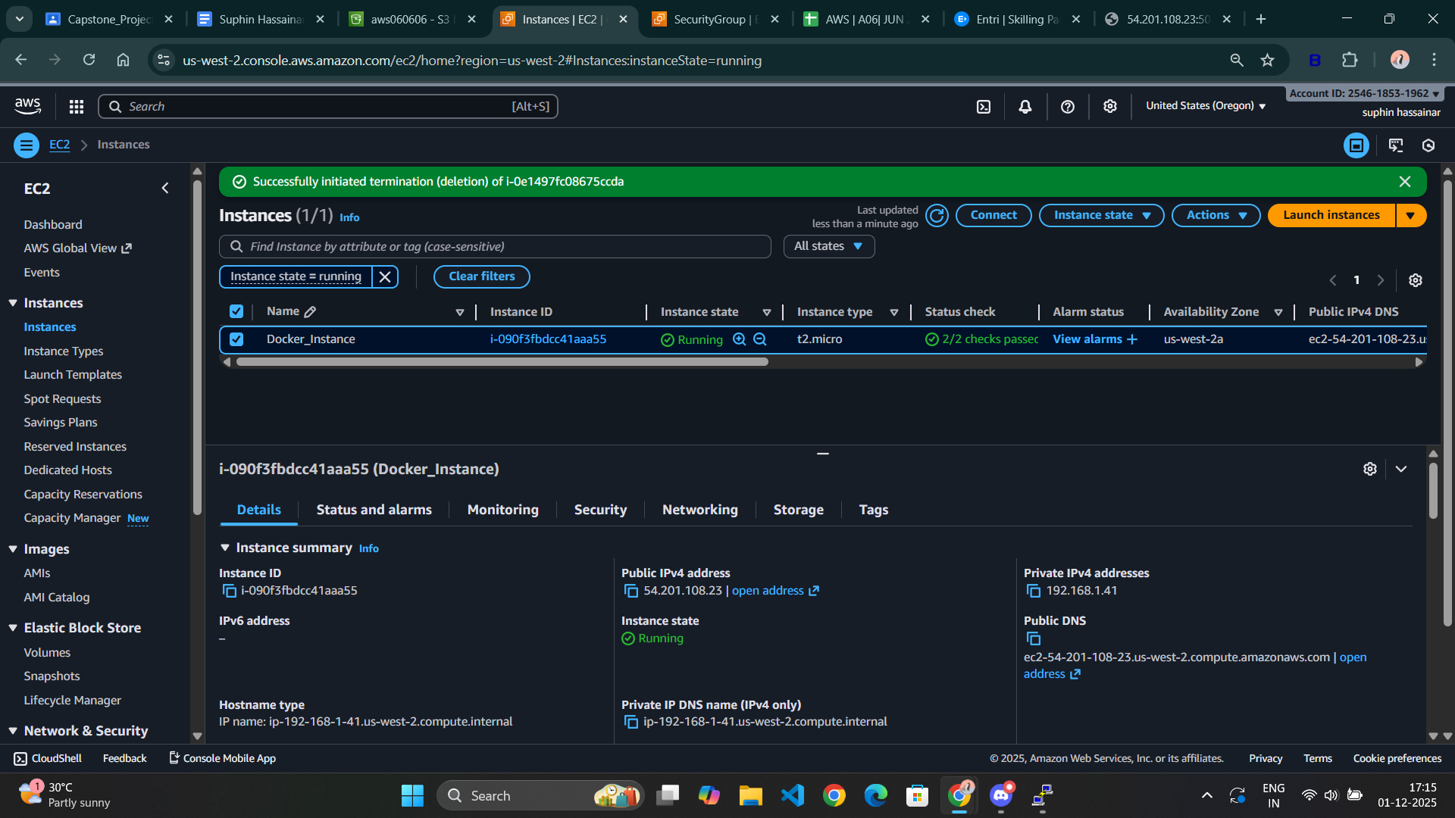

Docker & Docker Compose Installed
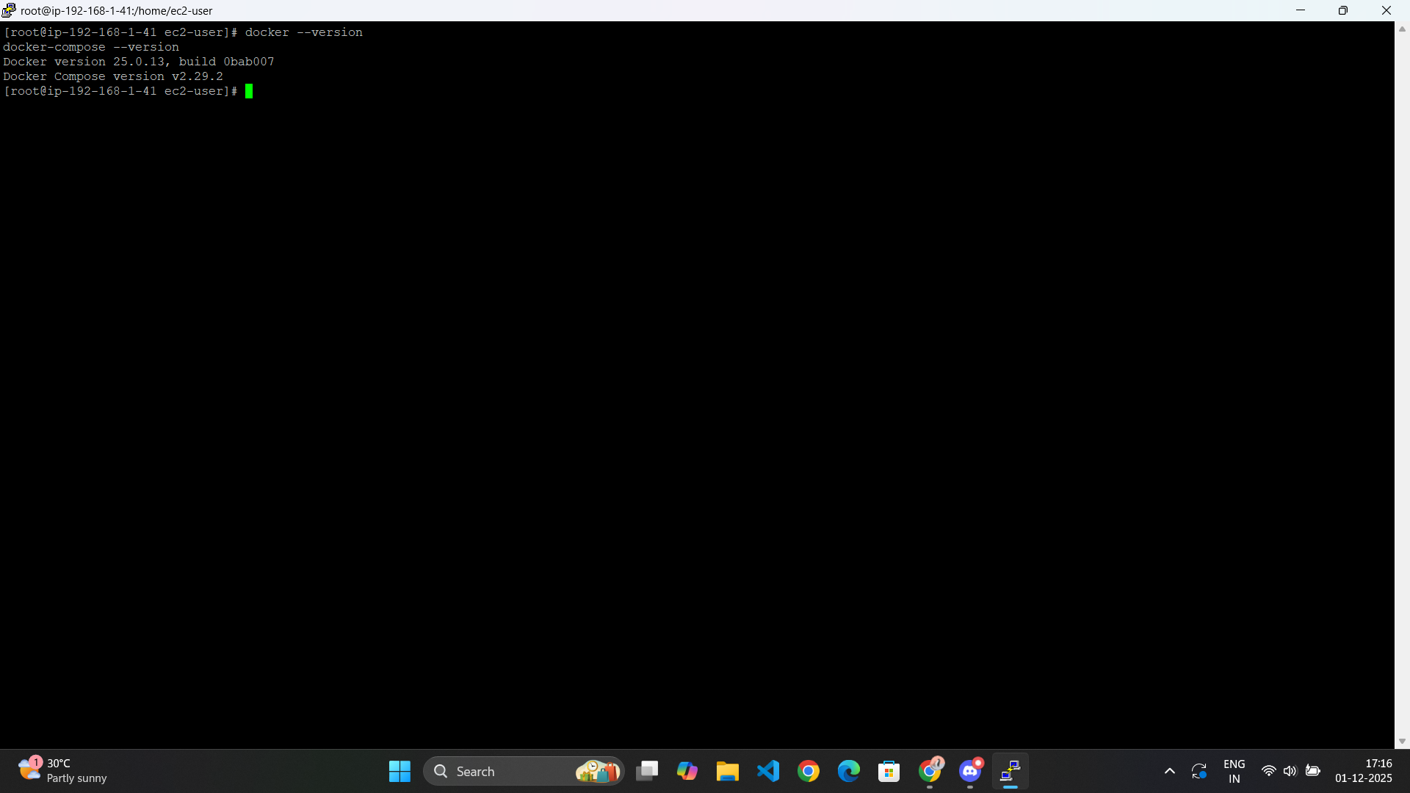

Project Files Present on Server
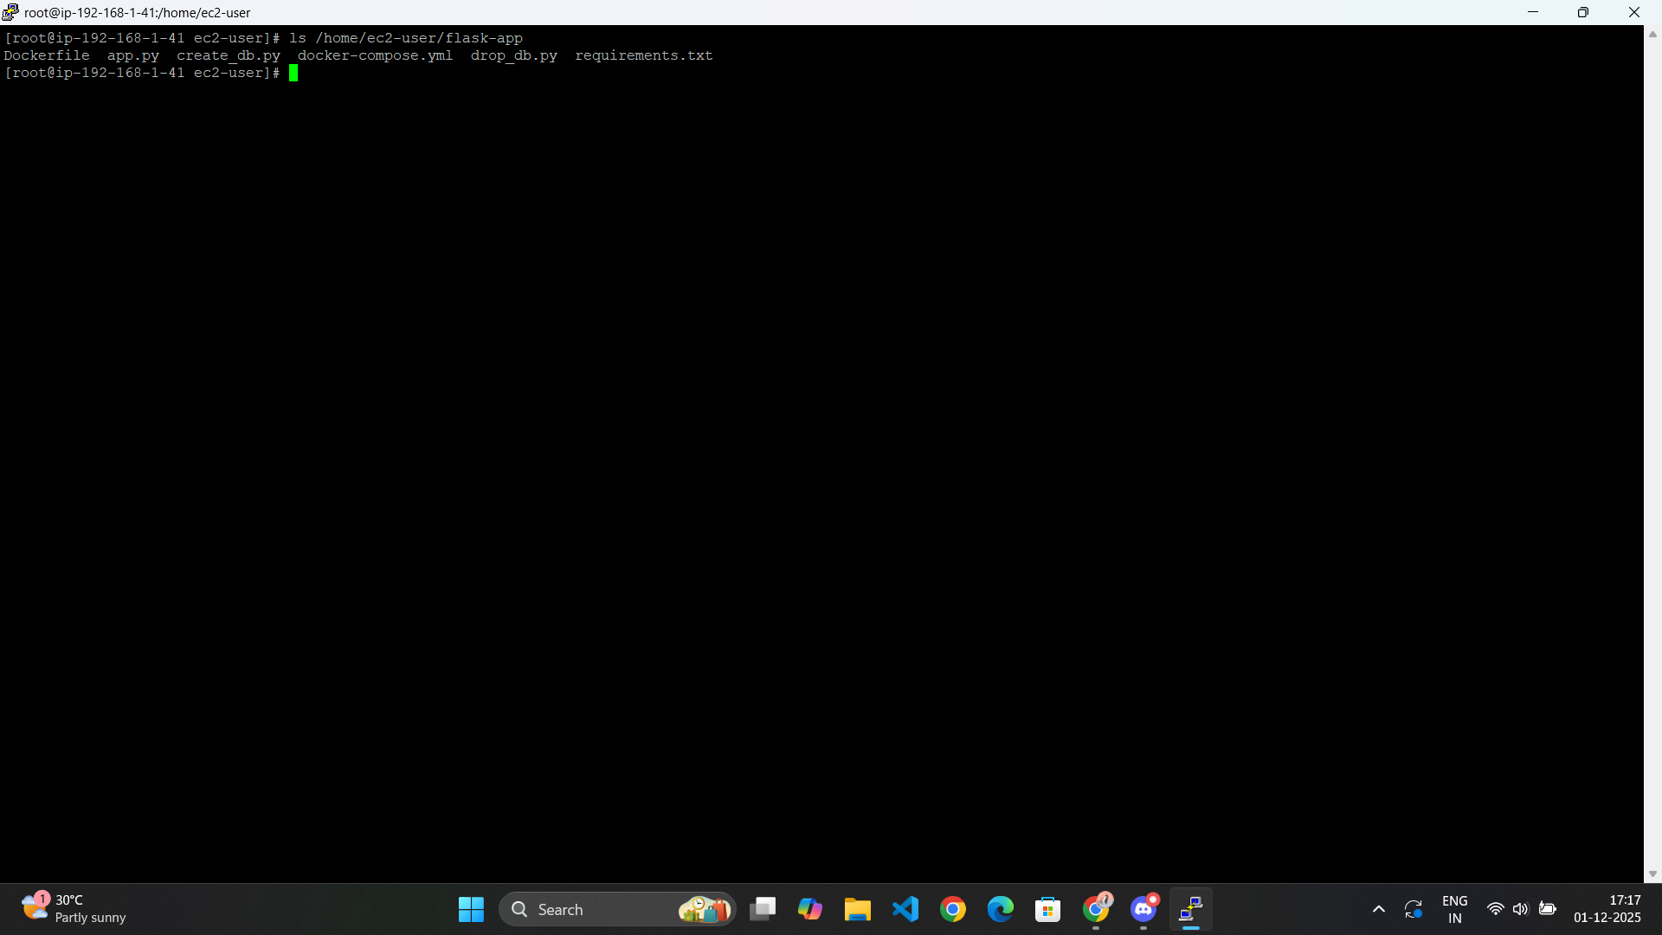

Successful Docker Build + Containers Running
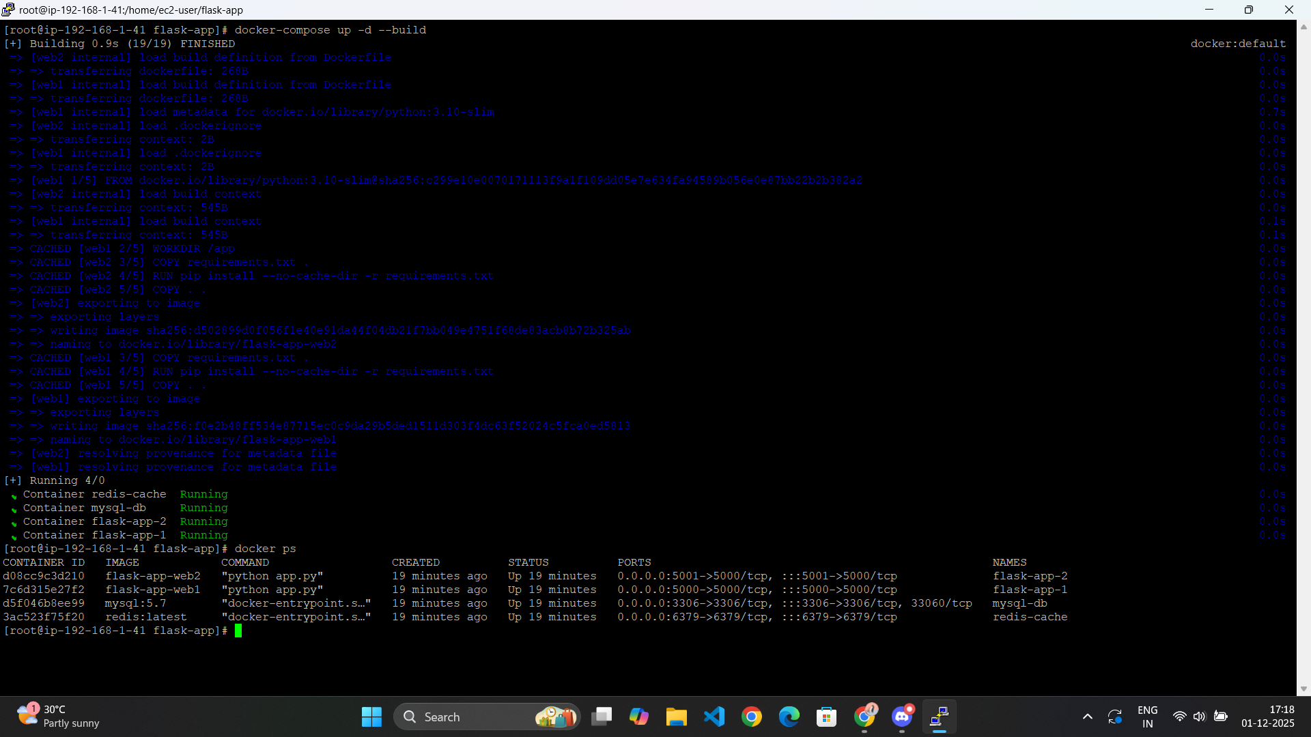

Database Creation Successful
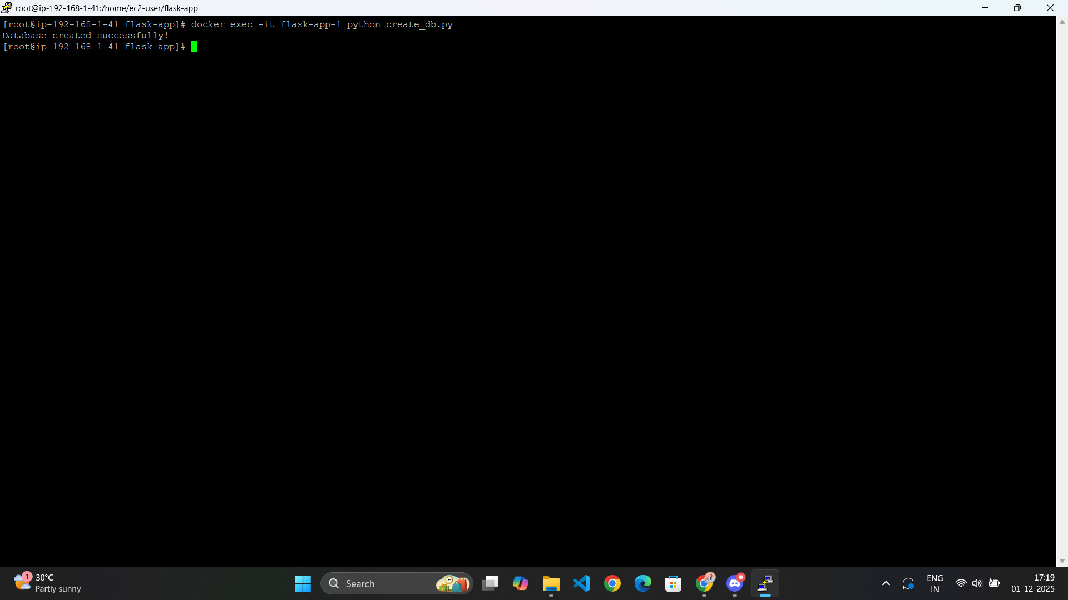

App running in Browser
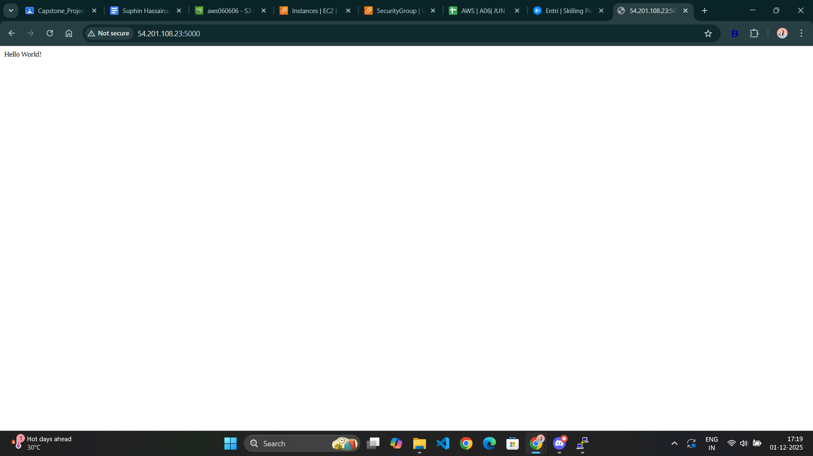

/status Endpoint
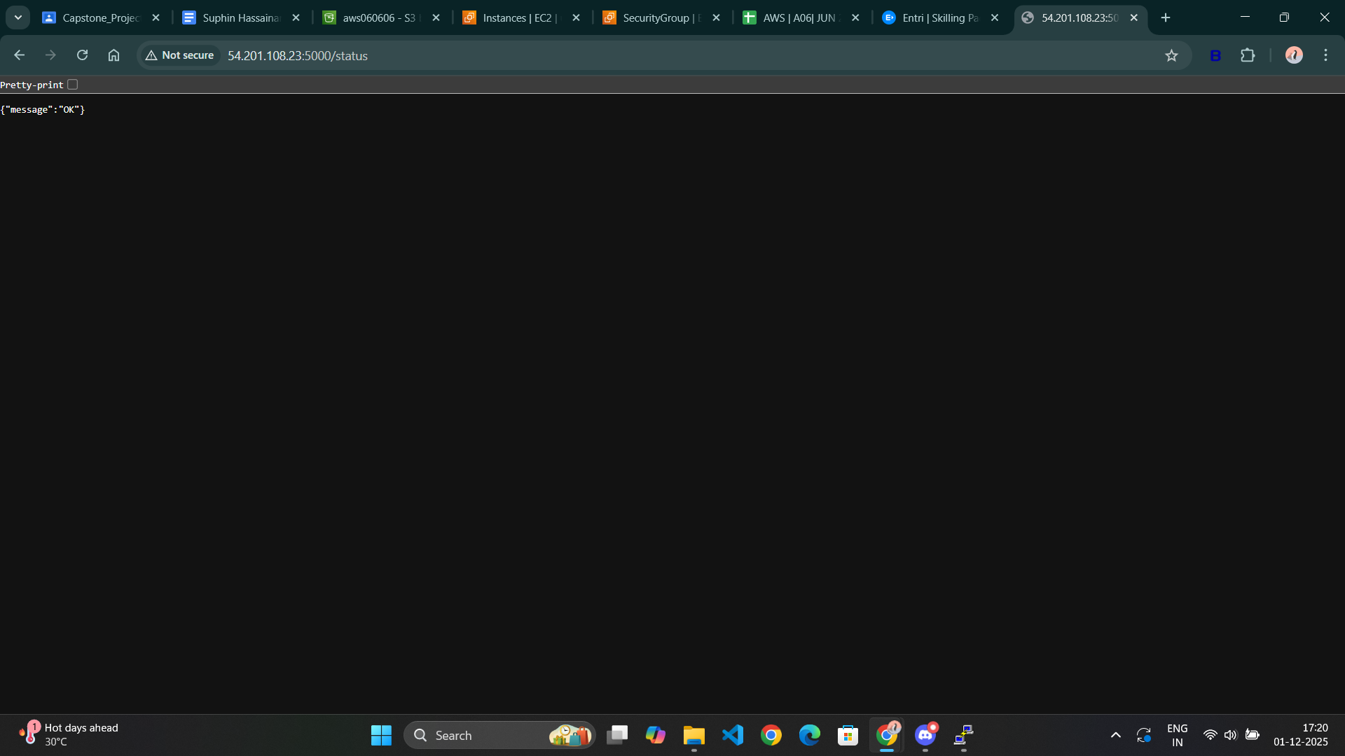

Palindrome Endpoint
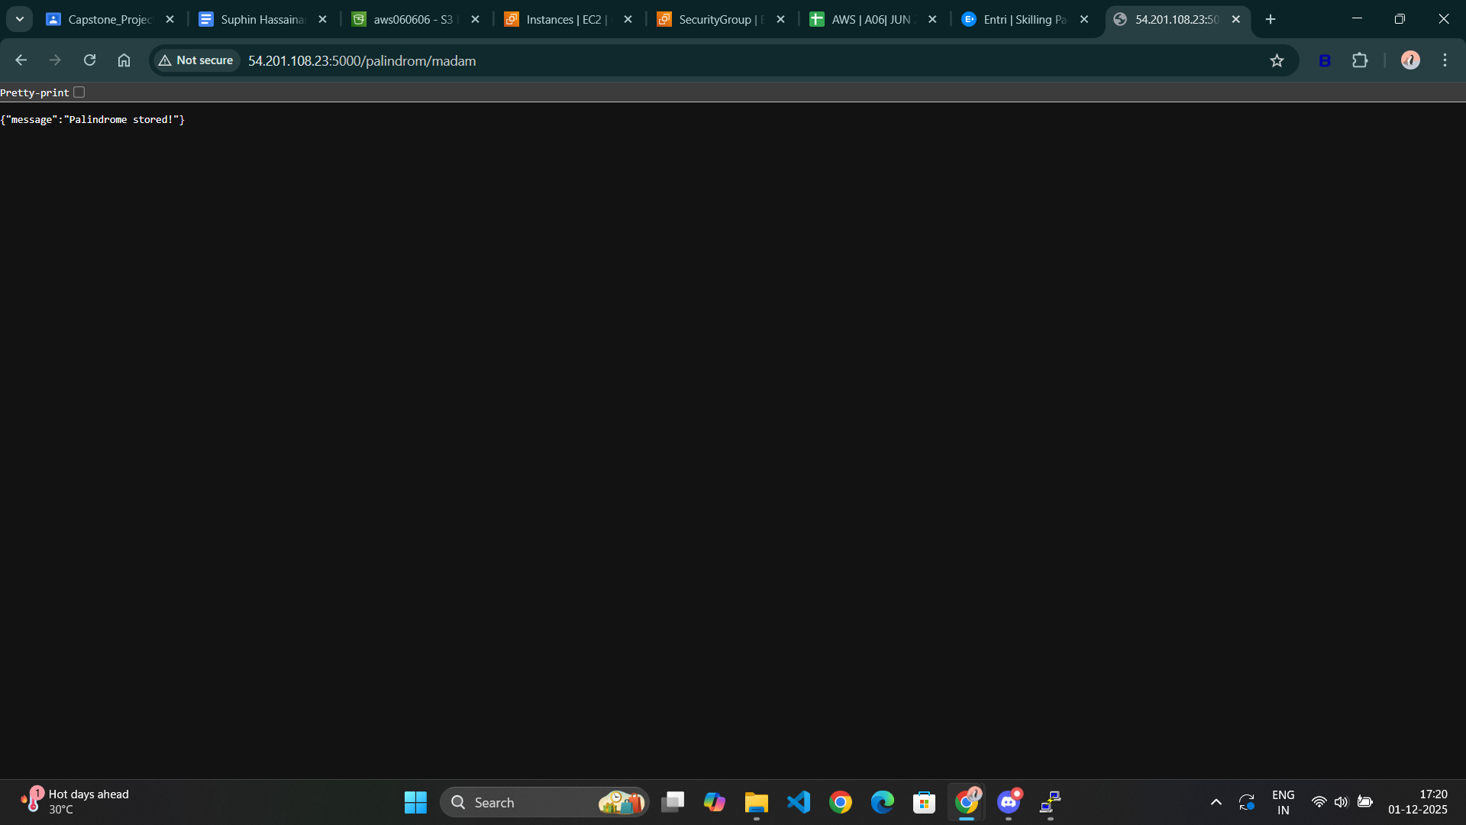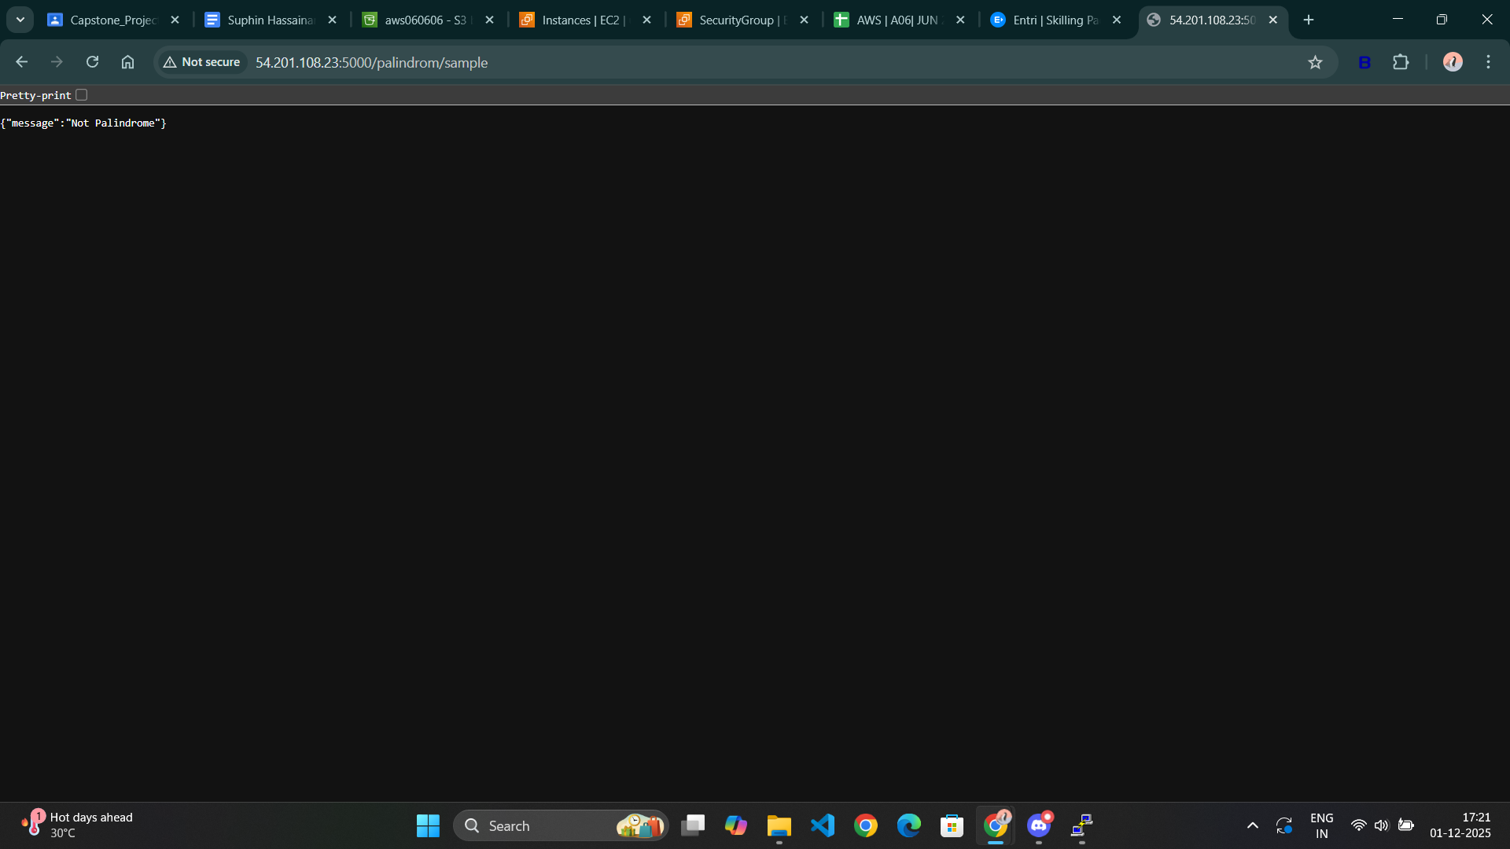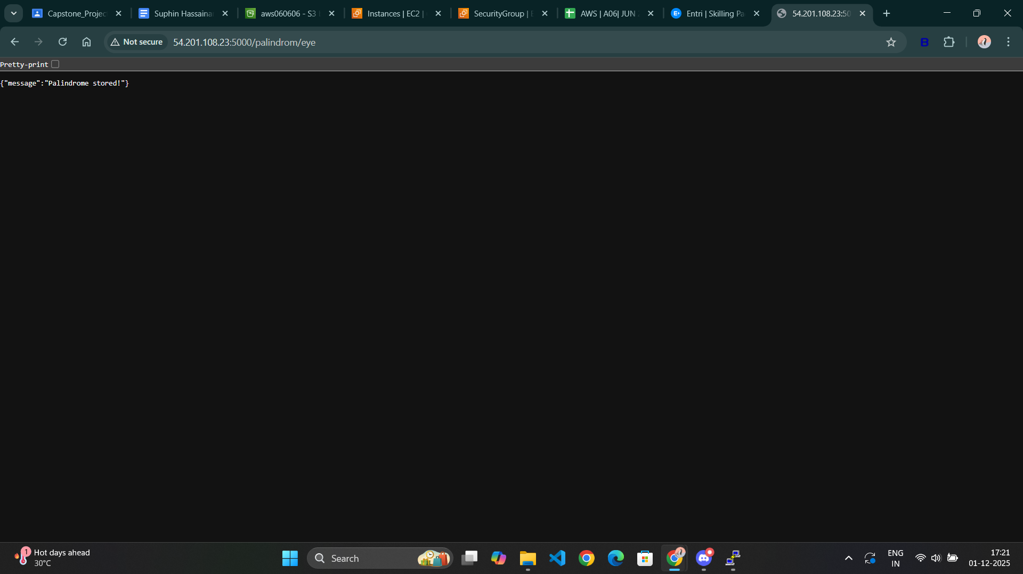

/admin Endpoint
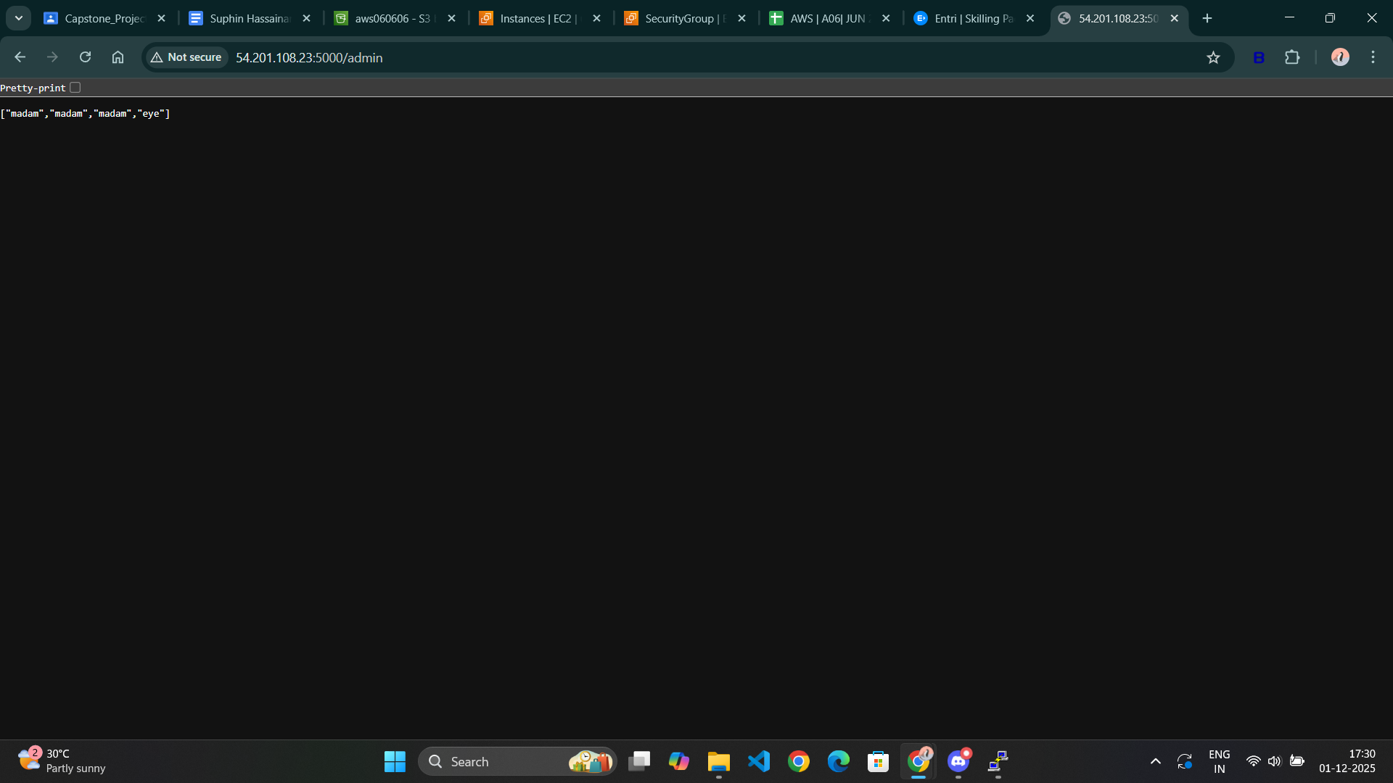

Redis Cache Working
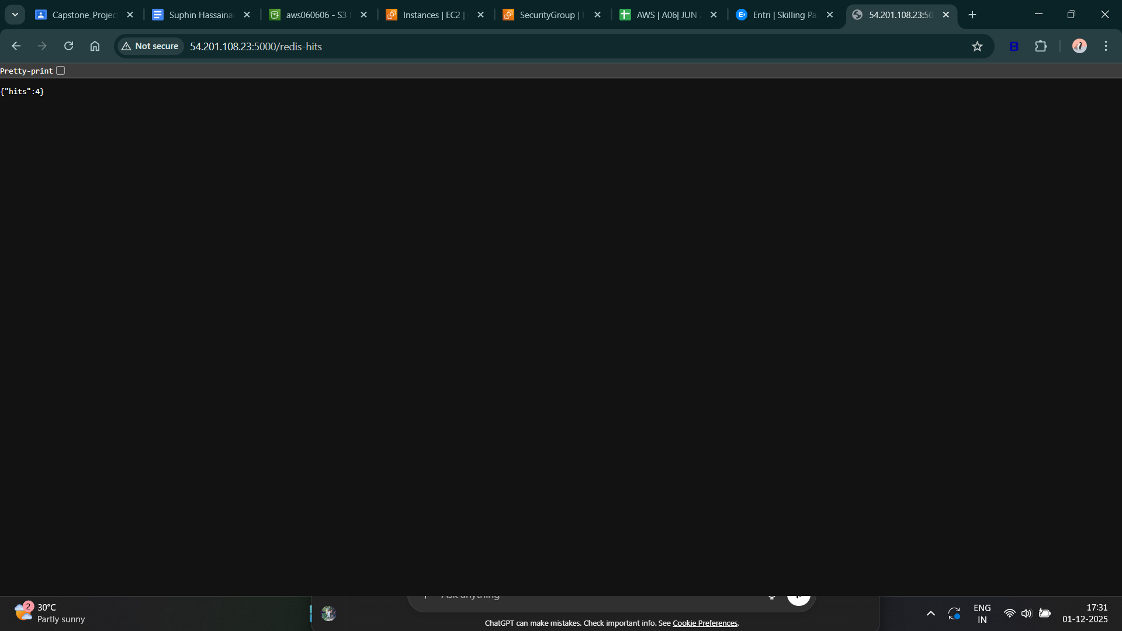

Restart Proof
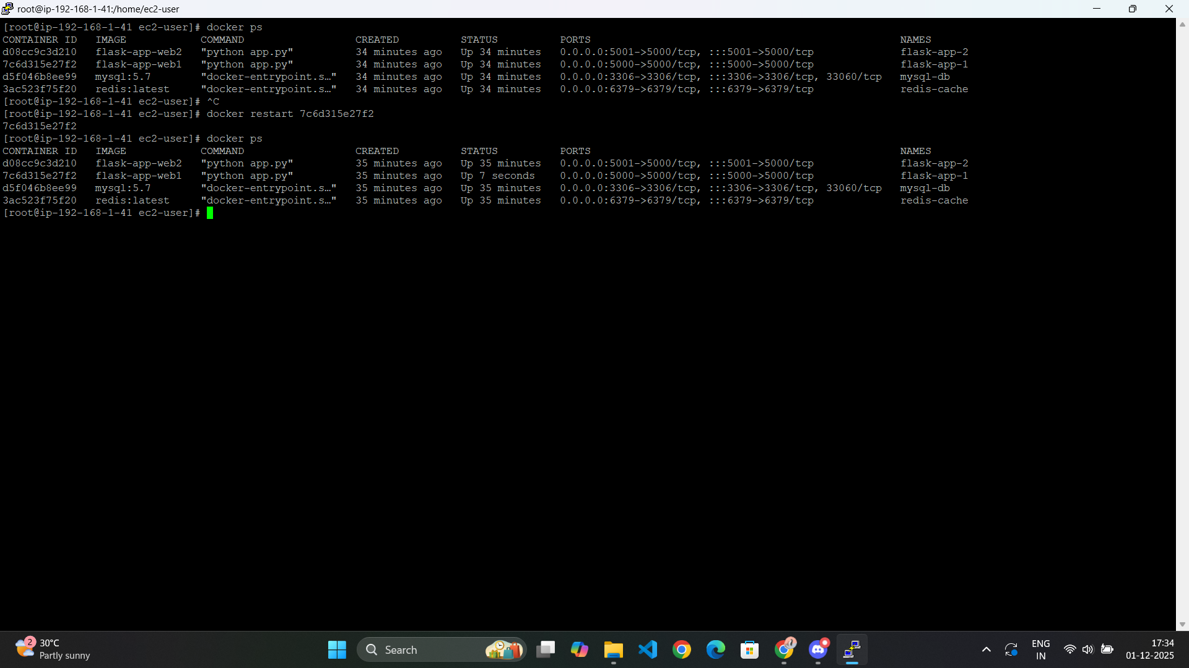

Deployment-Report

1. Project Overview
This project focuses on containerizing a Python Flask REST application and deploying it using Docker Compose.
The deployed solution includes multiple containers running the application, a MySQL database for storing palindromes, and a Redis service used for caching.
The objective is to enable a fully functional multi-container DevOps setup that can run reliably and be accessed through HTTP.
The deployment follows DevOps best practices related to automation, isolation, and reproducibility.

2. System Architecture

Component | Technology Used | Function
flask-app-1 | Python Flask | Web application instance 1
flask-app-2 | Python Flask | Web application instance 2
mysql-db | MySQL 5.7 | Database for palindrome storage
redis-cache | Redis latest | Cache handling for redis-hits endpoint
docker-compose | Docker Compose | Manages and deploys multiple services

3. Environment Variables Used
Variable | Purpose | Example
APP_HOST | Application bind host | 0.0.0.0
APP_PORT | Application port | 5000
REDIS_HOST | Redis service hostname | redis
REDIS_PORT | Redis port | 6379
DATABASE_URI | Database connection string | mysql+pymysql://user:password@db:3306/palindromedb

4. Deployment Steps

Step 1: Install Docker and Docker Compose
sudo yum update -y
sudo yum install docker -y
sudo systemctl enable --now docker
sudo usermod -aG docker ec2-user
reboot
sudo curl -L "https://github.com/docker/compose/releases/download/2.29.2/docker-compose-$(uname -s)-$(uname -m)" -o /usr/local/bin/docker-compose
sudo chmod +x /usr/local/bin/docker-compose
docker-compose --version

Step 2: Application Setup
mkdir flask-app
cd flask-app

Application files placed in this directory:
- app.py
- create_db.py
- drop_db.py
- requirements.txt
- Dockerfile
- docker-compose.yml

Step 3: Deploy Application Stack

docker-compose up -d --build
docker ps

Initialize database tables:
docker exec -it flask-app-1 python create_db.py

5. Testing and Verification

Endpoint | Expected Output | Status
/ | Hello World | Working
/status | {"message": "OK"} | Working
/palindrom/ | Stores palindrome and returns JSON response | Working
/redis-hits | Redis counter output increments | Working
/admin | Should display stored palindromes | Not tested (optional)
/prepare-for-deploy | Pre-deployment message | Not tested (optional)
/ready-for-deployment | Confirmation message | Not tested (optional)

7. Challenges and Resolutions

Issue Faced | Resolution
Docker Compose version structure warnings | Updated Compose file format properly
MySQL connection issues initially | Correct ENV and service dependency settings used
Permission restrictions on files | Handled using correct ownership and execution commands

8. Conclusion
The project meets all the required assignment criteria:
- Flask application containerized successfully
- Multiple container replicas running
- MySQL database integrated and functional
- Redis caching operational
- Application accessible through EC2 Public IP over HTTP
- Deployment automated using Docker Compose

